웹프로그래밍 과제13 컴퓨터소프트웨어공학과 1-YA 20202296 전채린

[jquery01-03]

[소스코드]

<!DOCTYPE html>

<html lang="en">

<head>

<meta charset="UTF-8">

<title>Document</title>

<link rel="stylesheet" href="https://cdnjs.cloudflare.com/ajax/libs/animate.css/4.1.1/animate.min.css">

<style>

@keyframes test {

20% { color: pink; }

50% { color: orange; }

100% { color: mediumpurple; }

}

h1 {

color: yellowgreen;

animation: test 3s 5;

}

h2 { color: skyblue; }

.animate bounce { animation: 5s 1s }

</style>

<script src="http://code.jquery.com/jquery-3.3.1.js">

</script>

<script>

$(document).ready(function() {

$(".id1").css("color", "yellowgreen");

$(".id1").css("border", "2px solid pink");

});

</script>

</head>

<body>

<h1>homepage</h1>

<h2 class="animate__animated animate__bounce">animate.css 적용</h2>

<h3 class="id1">home</h3>

<h3 class="id1">menu</h3>

<h3 class="id1">mypage</h3>

<h3 class="id1">cart</h3>

</body></html>

[실행결과]

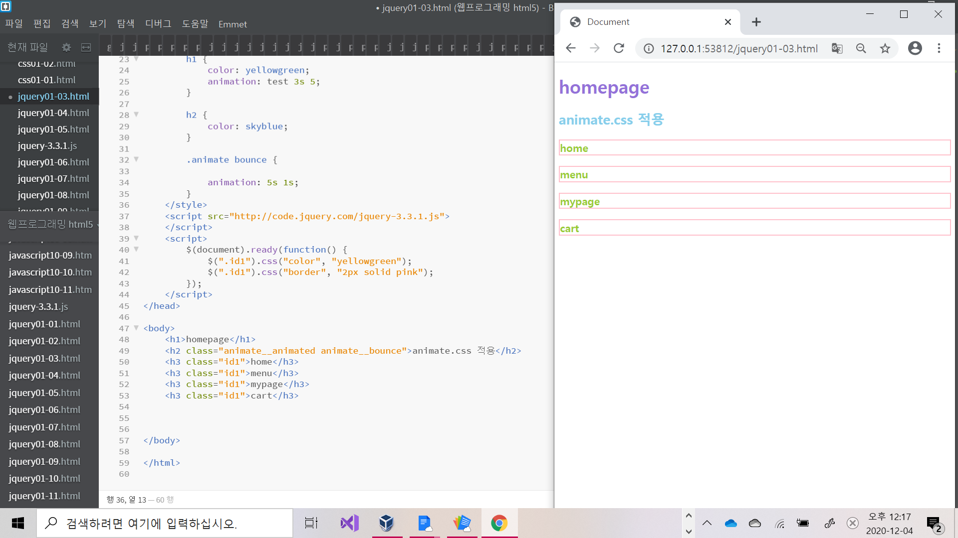

[jquery01-04]

[소스코드]

<!DOCTYPE html>

<html lang="en">

<head>

<meta charset="UTF-8">

<title>Document</title>

<script src="http://code.jquery.com/jquery-3.3.1.js">

</script>

<script>

$(document).ready(function() {

$('tr:odd').css('background', 'pink').css('color', '#fff');

$('tr:even').css('background', 'white');

$('tr:first').css('background', 'mediumpurple').css('color', '#fff').css('font-weight', 'bold');

$('tr:last').css('font-weight', 'bold');

});

</script>

</head>

<body>

<table>

<tr>

<td>이름</td>

<td>혈액형</td>

<td>지역</td>

</tr>

<tr>

<td>chaerin</td>

<td>A형</td>

<td>서울특별시 구로구</td>

</tr>

<tr>

<td>boa</td>

<td>B형</td>

<td>미국 캘리포니아</td>

</tr>

<tr>

<td>nayoung</td>

<td>AB형</td>

<td>미국 메사추세츠</td>

</tr>

<tr>

<td>minsion</td>

<td>O형</td>

<td>서울 강서구</td>

</tr>

<tr>

<td>bada</td>

<td>A형</td>

<td>서울 송파구</td>

</tr>

<tr>

<td>yeejin</td>

<td>B형</td>

<td>부산 동구</td>

</tr>

</table>

</body></html>

[실행결과]

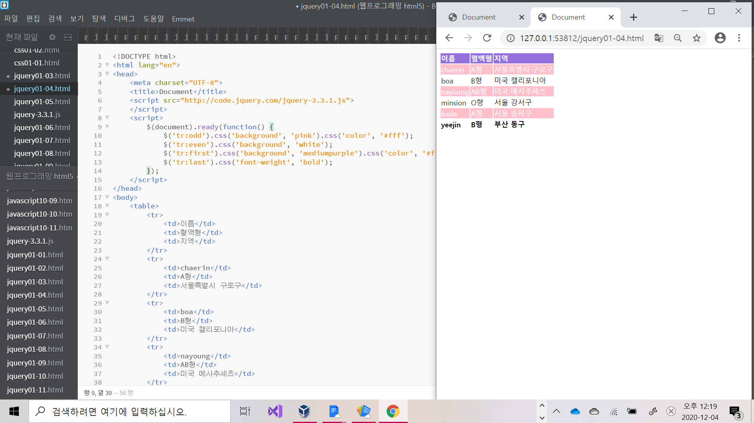

[jquery01-05]

[소스코드]

<!DOCTYPE html>

<html lang="en">

<head>

<meta charset="UTF-8">

<title>Document</title>

<script src="http://code.jquery.com/jquery-3.3.1.js"></script>

<script>

$(document).ready(function() {

$('*').css({

background: 'mediumpurple',

color: 'pink'

});

$('#hideP').click(function() {

$('p').hide();

});

$('#showP').click(function() {

$('p').show();

});

});

</script>

</head>

<body>

<h1>무료 나눔</h1>

<button id="hideP">텍스트 감추기</button>

<button id="showP">텍스트 표시하기</button>

<hr>

<p>품목 : 의류, 식품, 가전제품, 전자기기</p>

<p>대상 : 필요한 모든 분</p>

<p>일시 : 2020.12.31</p>

<p>연락처 : 010-4604-5578</p>

</body></html>

[실행결과]

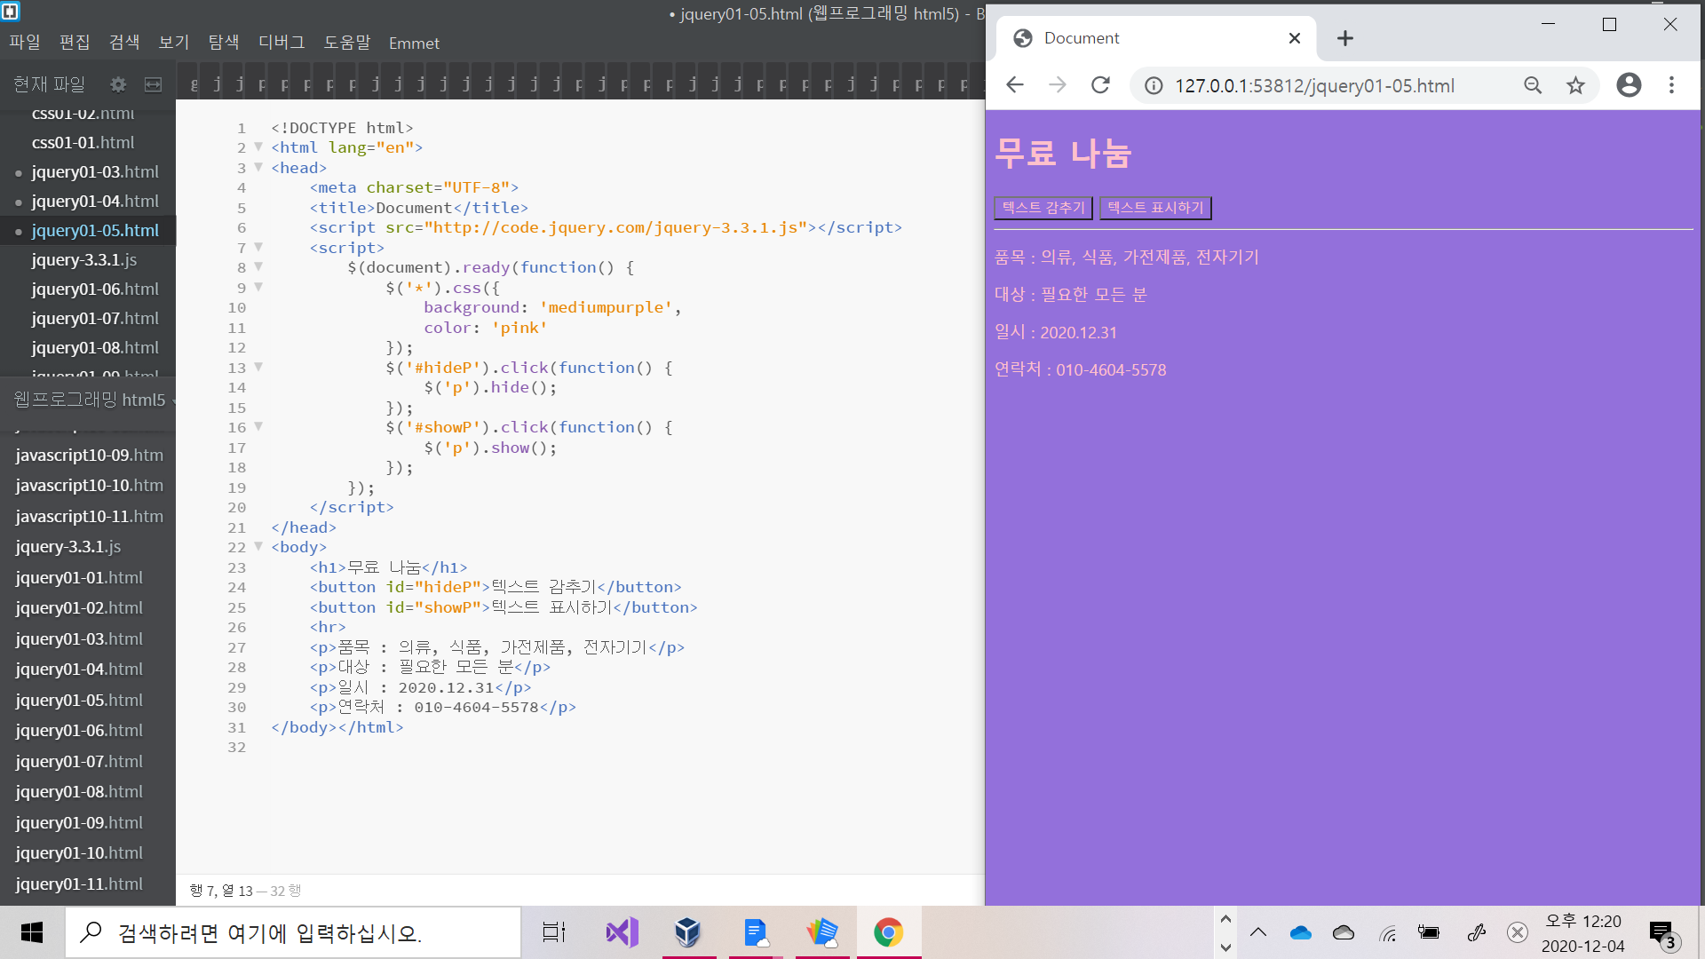

[jquery01-06]

[소스코드]

<!DOCTYPE html>

<html lang="en">

<head>

<meta charset="UTF-8">

<title>Document</title>

<script src="http://code.jquery.com/jquery-3.3.1.js">

</script>

<style>

#gallery {

margin-top: 5px;

width: 330px;

border: 2px solid black;

border-radius: 10px;

}

#gallery figure { margin: 10px 20px; }

</style>

<script>

$(document).ready(function() {

$('#btn1').click(function() {

$("figure").hide(2000);

$("gallery").css("border", "none");

});

$('#btn2').click(function() {

$("figure").show(2000);

$("gallery").css("border", "20px solid black").css("border.radius", "10px");

});

});

</script>

</head>

<body>

<button id="btn1">hide</button>

<button id="btn2">show</button>

<div id="gallery">

<figure>

<img src="./img/rose.jpg" alt="" width="300" height="200">

<figcaption><b>장미</b>

강렬한 빨간 장미 꽃다발</figcaption>

</figure>

</div>

</body></html>

[실행결과]

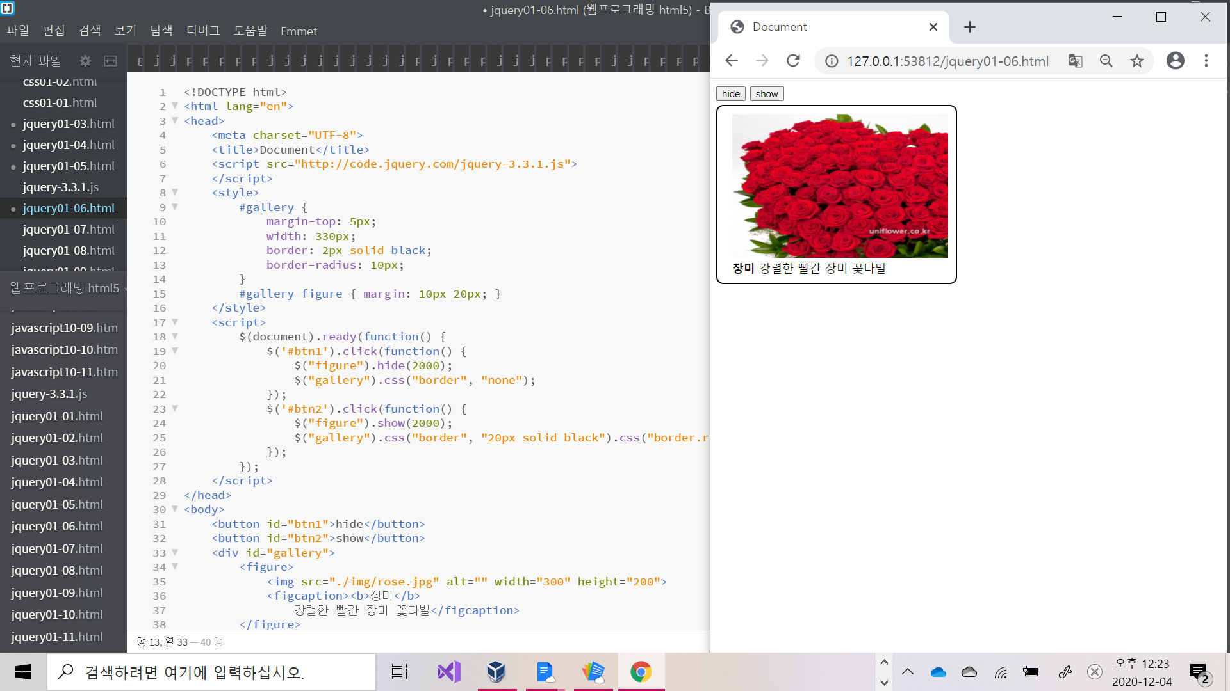

[jquery01-07]

[소스코드]

<!DOCTYPE html>

<html lang="en">

<head>

<meta charset="UTF-8">

<title>Document</title>

<script src="http://code.jquery.com/jquery-3.3.1.js">

</script>

<script>

$(document).ready(function() {

$('h3').filter(':odd').css({

backgroundColor: 'pink',

color: 'white'

});

$('h3').filter(':even').css({

backgroundColor: '#6e85d7',

color: 'white'

});

$('h4:odd').css({

backgroundColor: '#6e85d7',

color: 'black'

});

$('h4:even').css({

backgroundColor: 'skyblue',

color: 'white'

});

});

</script>

</head>

<body>

<h1>메뉴</h1>

<h3>파스타</h3>

<h3>리조또</h3>

<h3>피자</h3>

<h3>초밥</h3>

<h3>김치찌개</h3>

<h3>순두부찌개</h3>

<h4>짜장</h4>

<h4>짬뽕</h4>

<h4>탕수육</h4>

<h4>깐풍기</h4>

</body></html>

[실행결과]

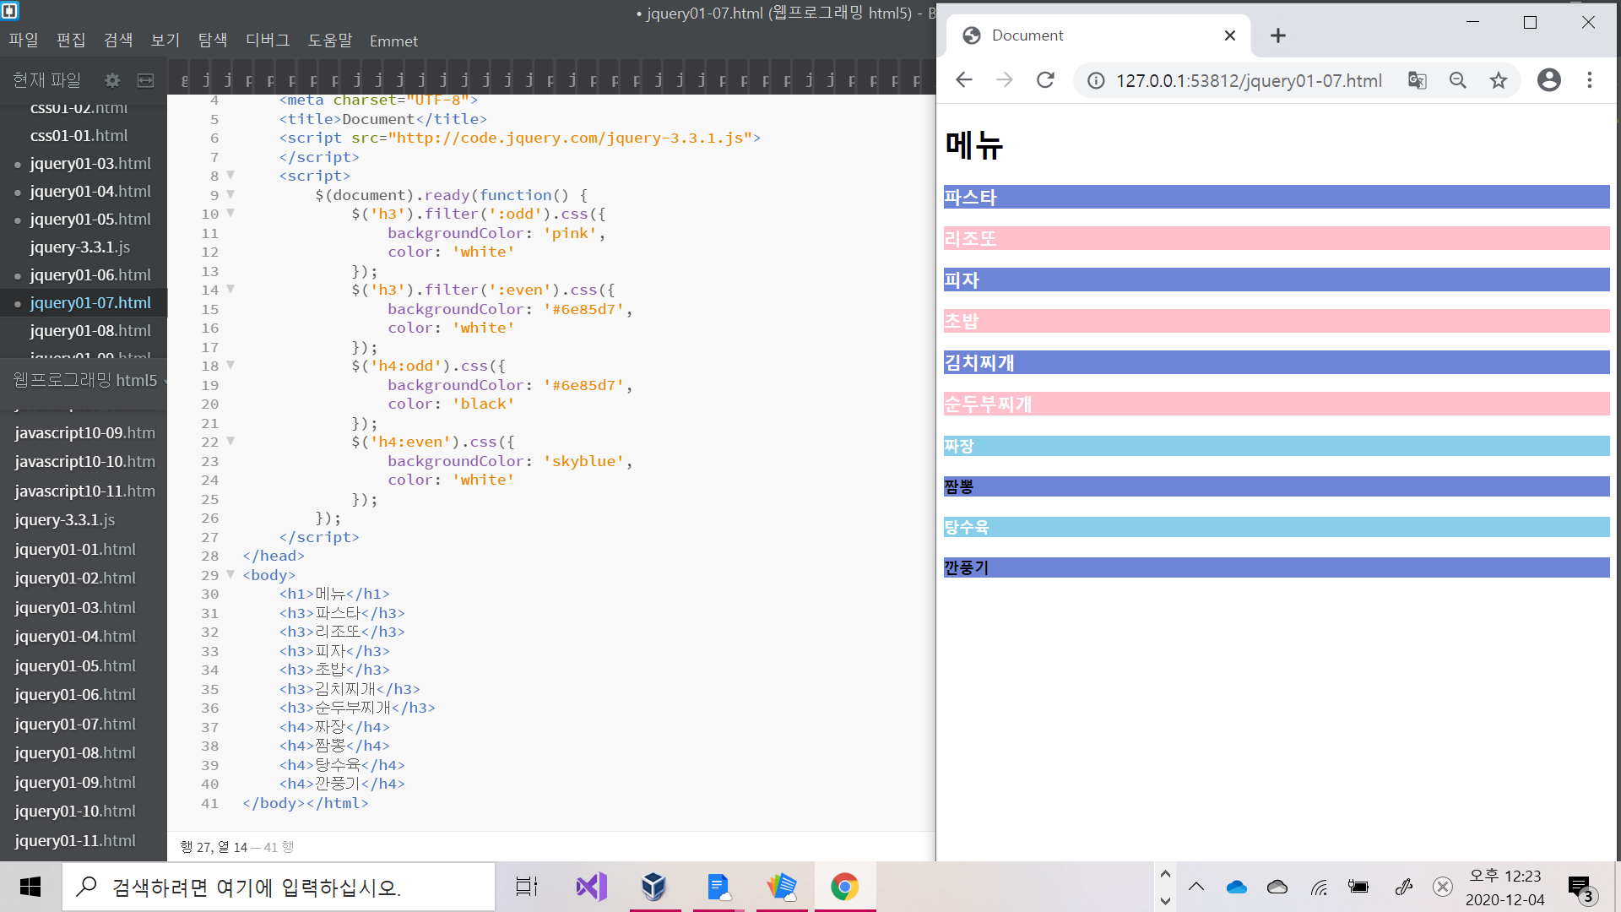

[jquery01-08]

[소스코드]

<!DOCTYPE html>

<html lang="en">

<head>

<meta charset="UTF-8">

<title>Document</title>

</head>

<script src="http://code.jquery.com/jquery-3.3.1.js">

</script>

<script>

$(document).ready(function() {

$('h3').eq(0).css('background', 'red').css('color', 'white');

$('h3').eq(1).css('background', 'orange').css('color', 'white');

// $('h3').eq(2).css('backgound', 'yellow');

$('h3').eq(-4).css('background', 'yellow');

$('h3').eq(-2).css('background', 'blue').css('color', 'white');

$('h3').eq(-1).css('background', 'purple').css('color', 'white');

});

</script>

<body>

<h3>웹프로그래밍 0</h3>

<h3>자바프로그래밍 1</h3>

<h3>자료구조 2</h3>

<h3>데이터베이스관리 3</h3>

<h3>운영체제실습 4</h3>

<h3>컴퓨터제어실습 5</h3>

</body></html>

[실행결과]

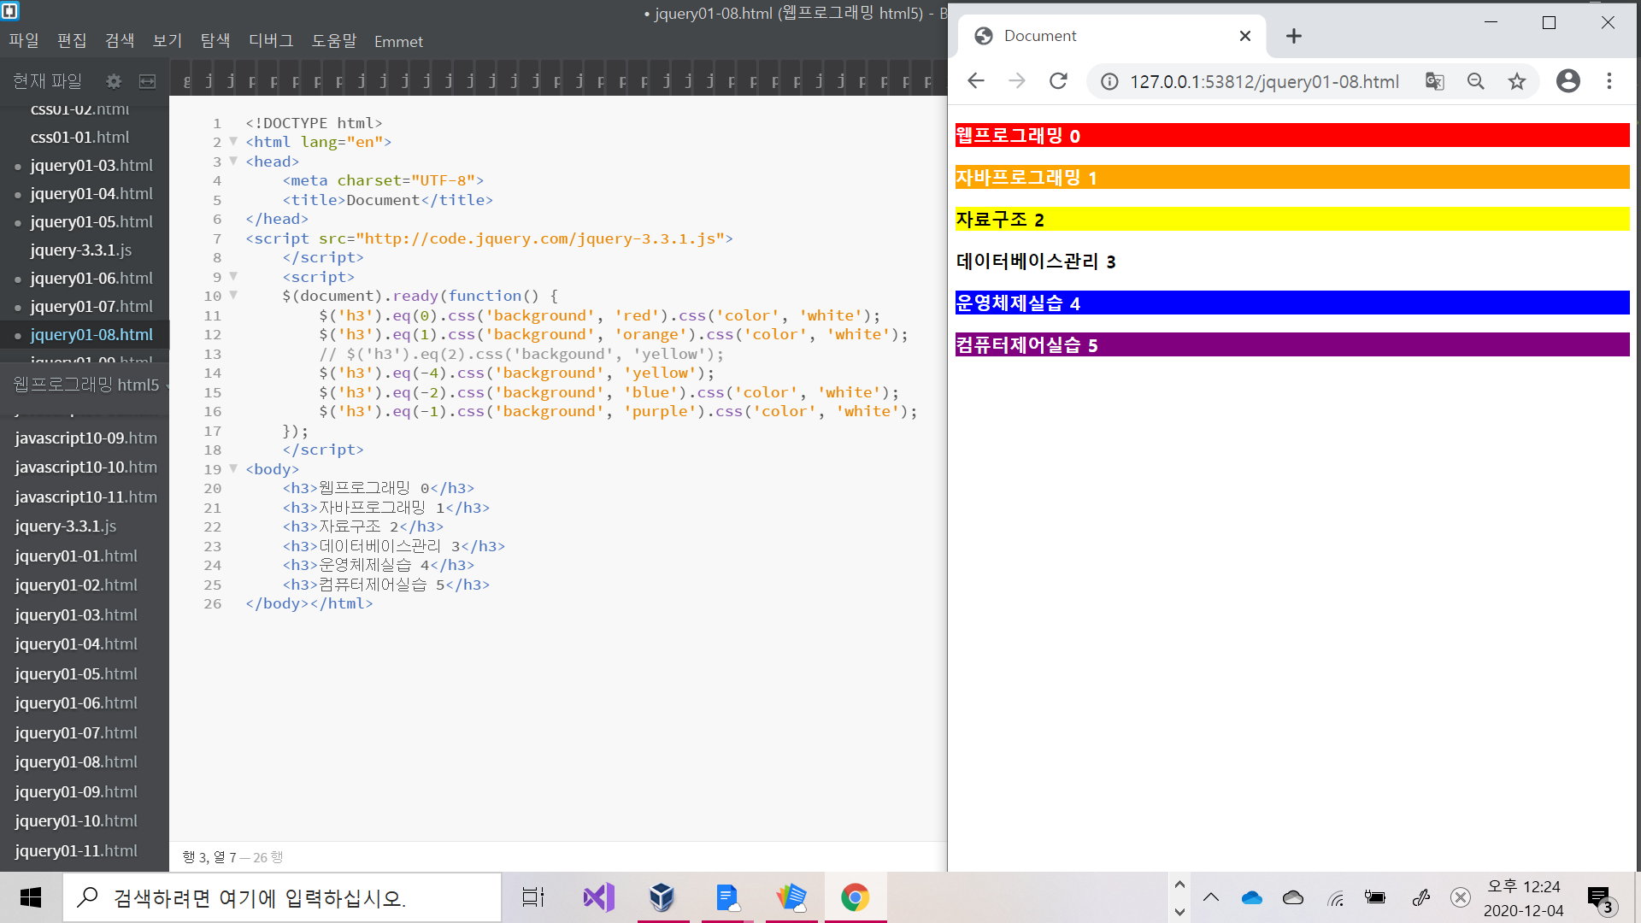

[jquery01-09]

[소스코드]

<!DOCTYPE html>

<html lang="en">

<head>

<meta charset="UTF-8">

<title>Document</title>

<style>

#title {

color: palevioletred;

border: 2px dotted orange;

}

.item { color: lightpink; }

</style>

<script src="http://code.jquery.com/jquery-3.3.1.js">

</script>

<script>

$(document).ready(function() {

$('h1').addClass('item');

});

</script>

</head>

<body>

<h1 id="title">겨울방학 계획</h1>

<hr>

<h1>웹프로그래밍</h1>

<h1>자바프로그래밍</h1>

<h1>c언어</h1>

<h2>알바</h2>

<h2>정보처리산업기사</h2>

</body></html>

[실행결과]

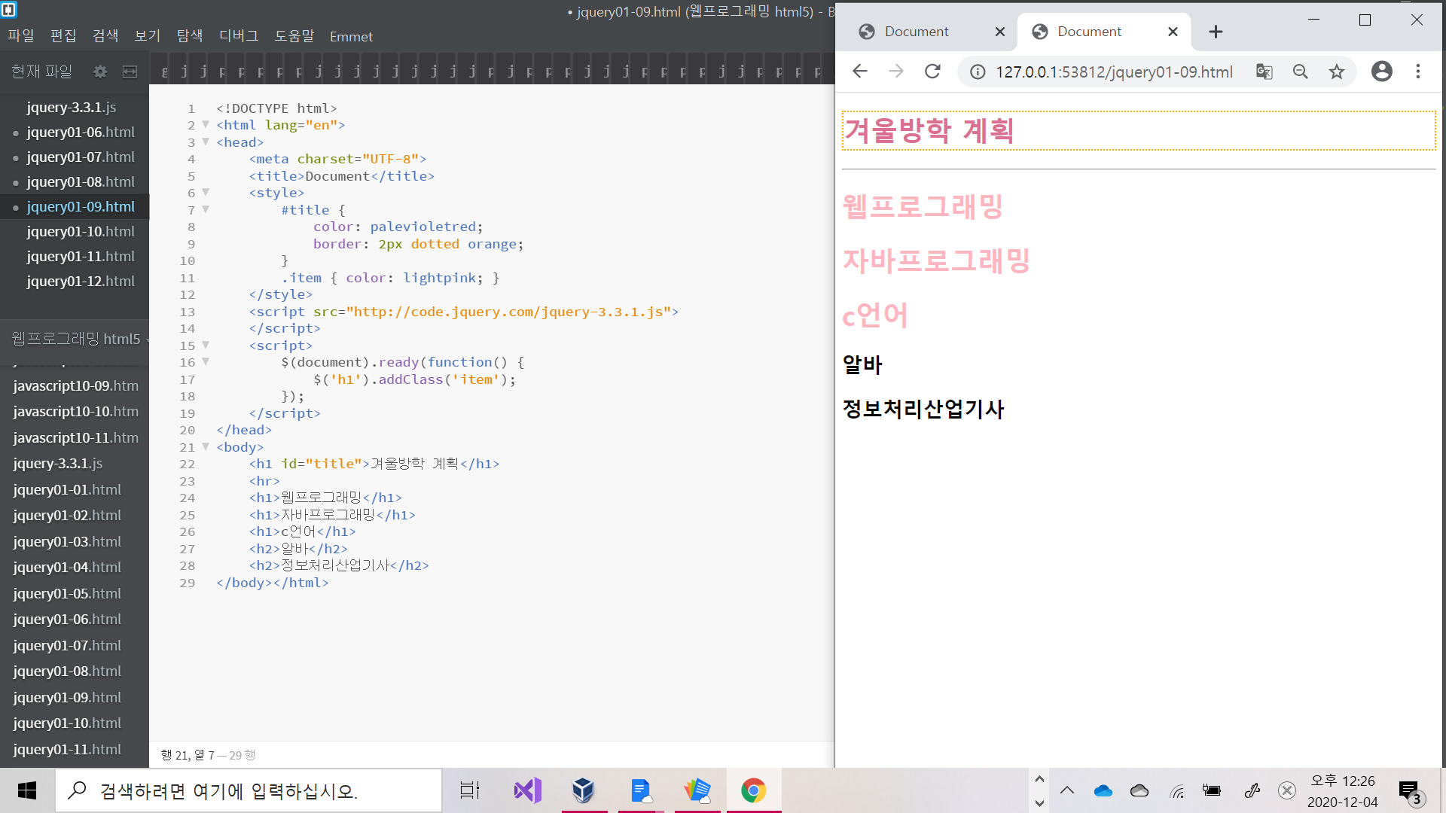

[jquery01-10]

[소스코드]

<!DOCTYPE html>

<html lang="en">

<head>

<meta charset="UTF-8">

<title>Document</title>

<style>

.class0 { color: blue; }

.class1 { color: magenta; }

.class2 { color: green; }

</style>

<script src="http://code.jquery.com/jquery-3.3.1.js">

</script>

<script>

$(document).ready(function() {

$('h1').addClass(function(index) {

return 'class' + index;

})

});

</script>

</head>

<body>

<h1>웹프로그래밍</h1>

<h1>자바스크립트</h1>

<h1>CSS</h1>

</body></html>

[실행결과]

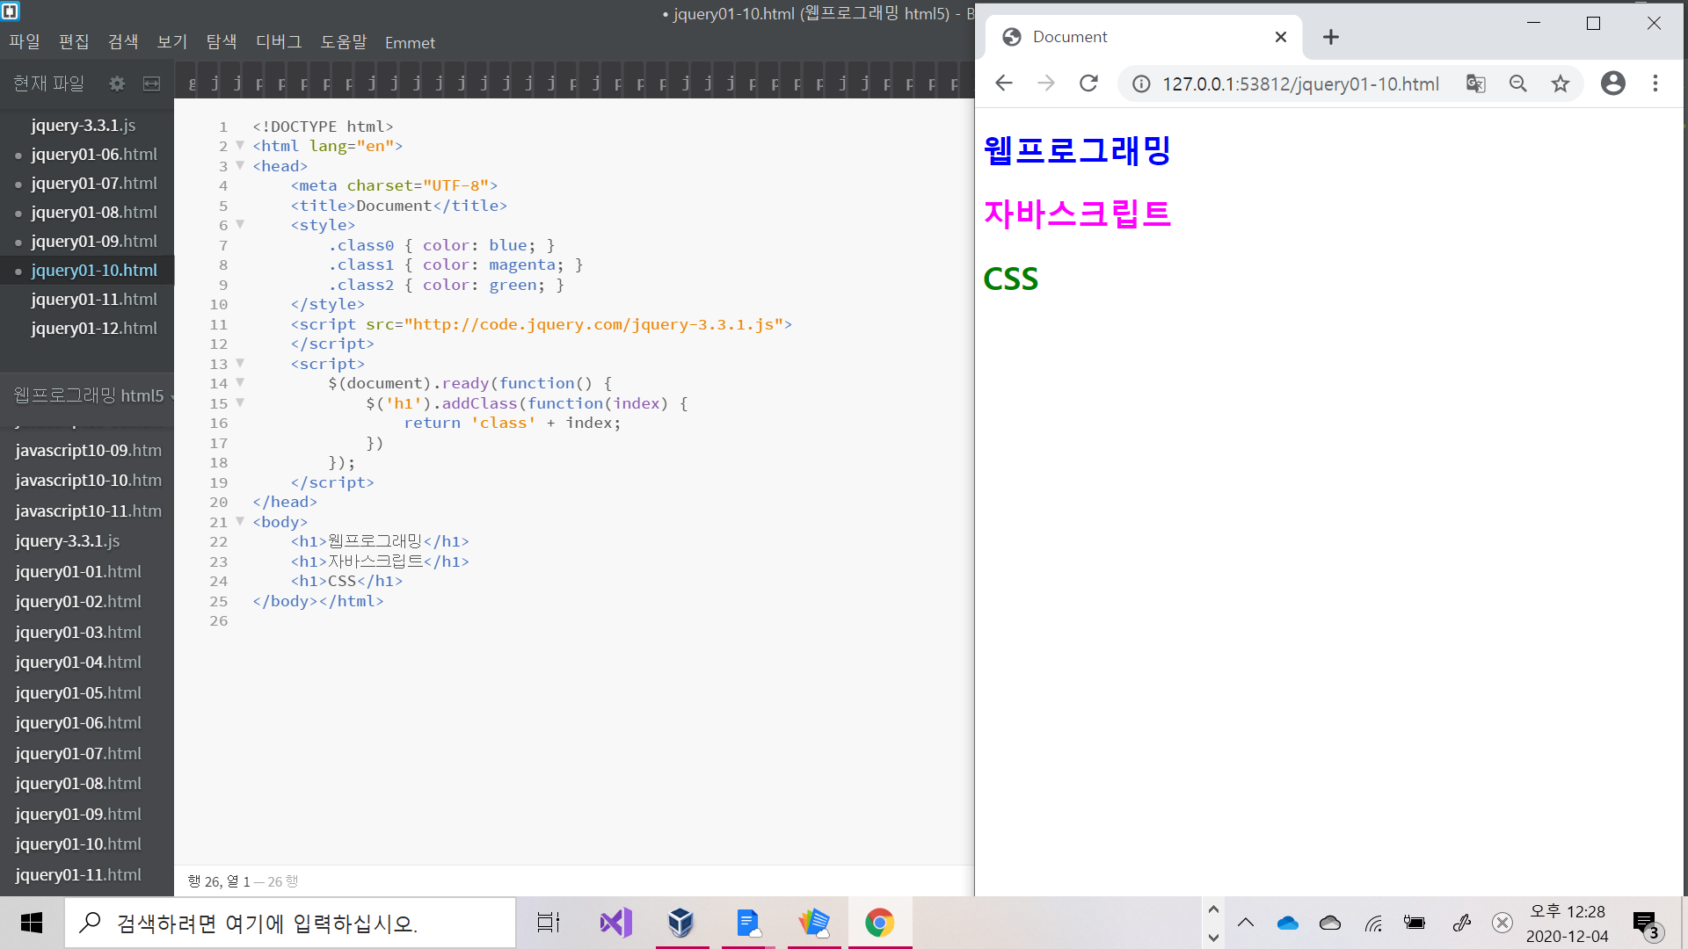

[jquery01-11]

[소스코드]

<!DOCTYPE html>

<html lang="en">

<head>

<meta charset="UTF-8">

<title>Document</title>

<script src="http://code.jquery.com/jquery-3.3.1.js">

</script>

<script>

$(document).ready(function() {

var str = $('img').attr('src');

alert(str);

var msg = $('img').attr('alt');

alert(msg);

$('img').attr('width', 300);

});

</script>

</head>

<body>

<img src="./img/strawberry.jpg" alt="딸기 사진입니다.">

</body></html>

[실행결과]

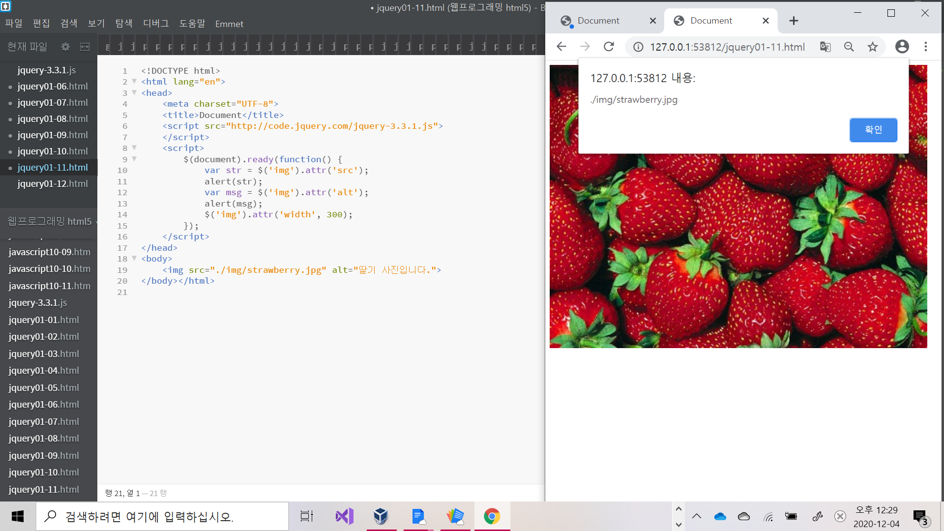

[jquery01-12]

[소스코드]

<!DOCTYPE html>

<html lang="en">

<head>

<meta charset="UTF-8">

<title>Document</title>

<script src="http://code.jquery.com/jquery-3.3.1.js">

</script>

<script>

$(document).ready(function() {

var col = ['red', 'orange', 'yellow', 'green', 'blue', 'purple'];

$('h1').css('color', function(index) {

return col[index];

});

});

</script>

</head>

<body>

<h1>dog</h1>

<h1>cat</h1>

<h1>rabbit</h1>

<h1>koala</h1>

<h1>elephant</h1>

<h1>horse</h1>

</body></html>

[실행결과]

